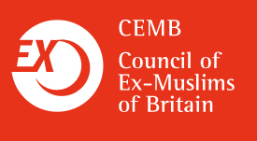

BM Box 1919, London WC1N 3XX
Tel: 07719166731
exmuslimcouncil@gmail.com
www.ex-muslim.org.uk

Ms Caroline Jones
Charity Commission Direct
PO Box 1227
Liverpool L69 3UG

August 8th 2011

Dear Ms Jones,

Thank you for your letter of April 15th 2011.

The Council of Ex-Muslims of Britain had applied for charity status, however your letter informed us that our objectives are not deemed to be exclusively charitable, therefore, our case for charity status has not been established.

I would like, if I may, to make a couple of points on your letter, and on other organisations which have indeed been granted charity status by the Charity Commission.

Your letter states that we are not exclusively charitable because our objectives “may be capable of extending to non charitable purposes and purposes for which the public benefit cannot be established”. You then cite demands within our manifesto which you deem to be of a political nature, such as public debate, discussion, and campaigning. However, all of the demands within our manifesto are for recognised human rights – in particular the right to freedom of speech. It is the aim of the Council of Ex-Muslims of Britain to provide a safe place for people to renounce Islam and to advance human rights (such as the right to freedom of speech and conscience) in doing so. The advancement of human rights is a charitable purpose under section 2 of the Charities Act. Can I ask why this does not suffice, and how it is that the advancement of human rights can ever be deemed to be entirely non-political? How does the advancement of the human rights of freedom of speech and conscience not benefit the public? Furthermore, could you please explain whether the restriction on political activity applies only to secular or atheist organisations, or does it apply to religious organisations also?

To assist you in assessing my questions, I would like to draw your attention to the work of the Islamic Sharia Council (Registered charity number 1003855). On its website, the Islamic Sharia Council encourages polygamous marriage, advises women to remain within violent marriages, advises women that they do not have the right to refuse sex to their husbands, and advises that a woman’s testimony is worth less than a man’s because her mind is not as steady as his. Can you please explain how you deem this activity to be in the public interest? Indeed, can you also explain how these activities do not amount to being entirely non-political?

It is also widely known that the Islamic Sharia Council operates makeshift ‘courts’ across Britain, in which a woman’s word is deemed to be worth half of a man. Indeed, such organisations openly admit that they are hearing cases of domestic violence and marital rape (i.e. criminal offences, can you please point to the section of the Charities Act which allows such activity?). These cases are heard within a context where a woman has no right to refuse sex and violence against women is permitted (provided it does not leave marks). Can you please explain how this amounts to a public benefit, and is entirely non-political?

I look forward to receiving your response.

Sincerely yours
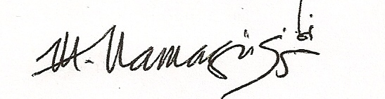
Maryam Namazie
Spokesperson
Council of Ex-Muslims of Britain

